ONE-WAY ROAD CLOSURE -V2

Stoke Lane, Frenchay

From 00:01 Monday 27th June until approximately Spring 2017

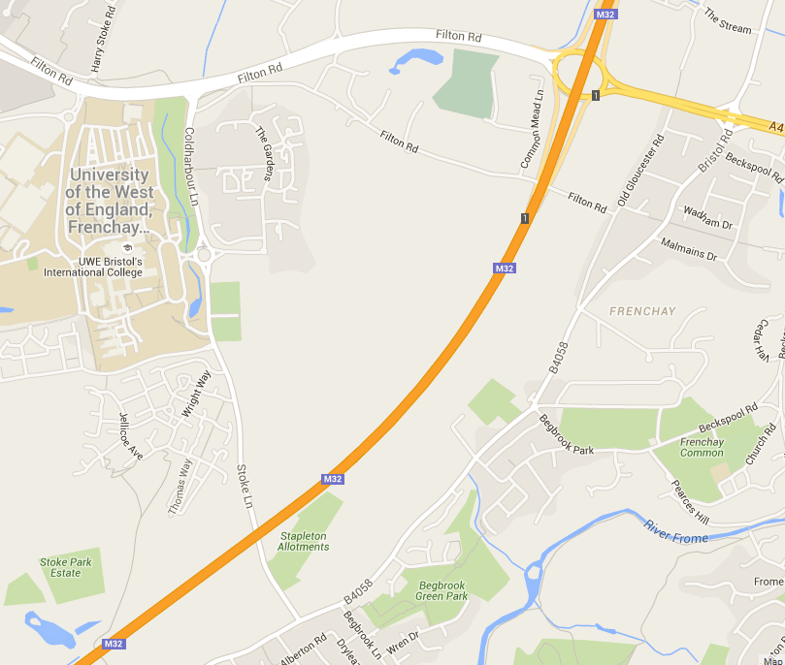
Services 16 & 48A normally operating northbound on Stoke Lane diverted via Frenchay Park Road, Bristol Road, A4174 and Coldharbour Lane
Service 18, 18A & 19 to UWE
Services 18, 18A, 19, X47 & X48 to use new stop on A4174 prior to Hambrook junction
ALL STOPS ON DIVERSION ROUTE AVAILABLE FOR USE UPON REQUEST
Stoke Lane closed NORTHBOUND ONLY until approximately spring 2017
Southbound services 16, 18, 18A & 48A normal route

ALL STOPS ON DIVERSION ROUTE AVAILABLE FOR USE UPON REQUEST

If you are unsure about this diversion, please contact a member of your Depot Management Team prior to commencement of your duty.

