Drop-in Event
15 January 2018
3.30pm – 8.30pm
Frenchay Village Hall

Proposal to enlarge
Frenchay CE Primary School

January 2018

South Gloucestershire Council is seeking your views on a proposal to enlarge Frenchay CE Primary School.

A drop-in event is planned in order to share details on the proposal with interested parties. The event will take place on Monday 15 January 2018 between 3.30pm – 8.30pm at Frenchay Village Hall, Beckspool Road, Frenchay, Bristol BS16 1NU.

The drop-in event will provide parents/carers of children attending Frenchay CE Primary School, and local residents, with the opportunity to discuss and comment on the proposals ask questions about the project, including how the scheme would be funded. Council officers, school staff and members of the governing body will be available to help explain the proposed scheme.

This paper explains:

- What is being proposed and why
- How it is proposed to fund the scheme
- What the next steps will be and how any decision will be made on the proposal
- What you can do to share your views/comments if you are unable to attend the drop-in event.

What is being proposed?

It is proposed to enlarge Frenchay CE Primary School to provide a total of up to 420 primary school places. This would create an additional 280 places on top of the 140 primary school places already provided by Frenchay CE Primary School. It is proposed that this will be achieved by moving the existing school to a new site on land secured for primary school provision on the former Frenchay Hospital site. Under this proposal, it is proposed that Frenchay CE Primary School would operate from the new site/buildings from 1 September 2020.

Why is the Council proposing to enlarge Frenchay CE Primary School?

The Council monitors the impact of house building on the demand for school places to ensure there are sufficient school places to meet the needs of new and growing communities. Development of the former Frenchay Hospital site is estimated to yield an additional 180 primary school age children and will require the provision of additional primary school places. More generally, the Council is experiencing growing demand for primary school places and the Council is responding to this by increasing the availability of places at existing schools and commissioning new schools across South Gloucestershire.

Discussion over the years with Frenchay community representatives and the governing body of the school have indicated concern about the impact of the new housing and a possible new and separate primary school. The Council supports the local community’s aspiration for one school for Frenchay and, working with the Department for Education and the Diocese of Bristol, has considered options to achieve this.

The option to enlarge the existing Frenchay CE Primary School would:

- provide one school to serve the whole of Frenchay rather than two separate schools;
- provide the additional places necessary to meet growth arising from families moving into new homes;
- provide purpose built accommodation with all appropriate facilities to enhance the teaching and learning experience;
- provide additional primary school places to meet sustained growth in the future

It is important to emphasise that Frenchay CE Primary School would retain:

- the existing CE voluntary controlled legal status;
- the existing governing body;
- the existing leadership and staff.

Children on the roll of Frenchay CE Primary School would remain on roll and transfer automatically to the new school site unless parents wish otherwise.

Why is the Council proposing to transfer Frenchay CE Primary School to a new site?

There have been discussions over many years about improving the accommodation at Frenchay CE Primary School. The current school building is small and there is a backlog of repairs and maintenance works. Temporary accommodation on the school site provides additional classroom space though there is no option to expand the existing building to provide additional capacity on a permanent basis. There is not enough space to create a new primary school of appropriate size on the existing site which would meet required standards or future pupil numbers.

Within the development area on the former Frenchay Hospital site, the Council has negotiated the provision of land for a new primary school and a financial contribution towards the cost of building a new primary school. It is proposed to move the existing school to this new site. The new site on the development land is approximately 700 metres / 0.3 miles from the existing school. The location of both sites is set out in the attached aerial view of the area.

What would happen with the existing Frenchay CE Primary School site?

If the proposal to transfer Frenchay CE Primary School to a new site goes ahead, the existing school site would no longer be required for school use. The site is not owned by South Gloucestershire Council and will revert to the trustees of the school. The Council is in discussions with the Diocese of Bristol and the Trustees about the future of the site.

How would the scheme be funded?

The Council has secured a financial contribution from the developer for the provision of primary school places and this will be used to part-fund the scheme. The total contribution from the developer will not be enough to meet the total costs of the scheme and other sources of funding would need to be found. Additional funding could come from the sale of land at Malmains Drive in Frenchay and possibly, from the sale of the existing Frenchay CE Primary School site, subject to the outcome of discussions and negotiations with the trustees.

Next Steps and Decision Making Process

In advance of obtaining approval to enlarge the school, South Gloucestershire Council’s Cabinet will be asked to approve the updated capital programme for 2018/19. The updated programme will include details of the proposed capital scheme to enlarge Frenchay CE Primary School on the new site and will seek approval from councillors for the disposal of land at Malmains Drive. The Capital Programme report will be considered by Cabinet in February 2018.

The proposed transfer and enlargement of Frenchay CE Primary School is a major step. Following the drop-in session and in the event that approval for the scheme is given as outlined above, the Council will need to undertake the legal process for enlarging Frenchay CE Primary School. The table below sets out the legal process required. It is proposed that the Council will take a final decision by the end of the current academic year 2017/2018.

The statutory process for enlarging the school
Stage | Action | Timescale
Informal consultation | For a period of 6 weeks, the council will consult with parents/carers, local schools and stakeholders on the proposal to enlarge Frenchay CE Primary School | 1 February – 15 March 2018
Decision to proceed | The Council will consider all the responses received in the consultation and will decide whether to proceed to publish a statutory notice about the proposal. | 23 April 2018
Statutory Notice | The publication of a statutory notice with full details of the proposal | 30 April 2018
Representation Period | An opportunity for interested parties to make any comments on the proposal. | 30 April - 28 May 2018
Final Decision | The Council makes a final decision on whether to go ahead with the proposal bearing in mind all the details and all the comments which have been received. | 2 July 2018
Implementation | It is planned that Frenchay CE Primary School will operate with an increased admission number from the new site | 1 September 2020

How to make your views known if you are unable to attend the drop-in event

The Council understands that not everyone will be available to attend the drop-in event. If you have an interest in the proposal and want to share your views or comments, please complete the attached proforma and submit it no later than 5pm Wednesday 24 January 2018 by email or post as follows:

tanya.smith@southglos.gov.uk

Or, by post at the following address:

Tanya Smith
Strategic Lead - School Place Planning
Department for Children, Adults and Health
PO Box 1955, Bristol. BS37 0DE

Please ensure that your comments reach the Council by 24 January 2018 by 5pm.

Existing and new site locations
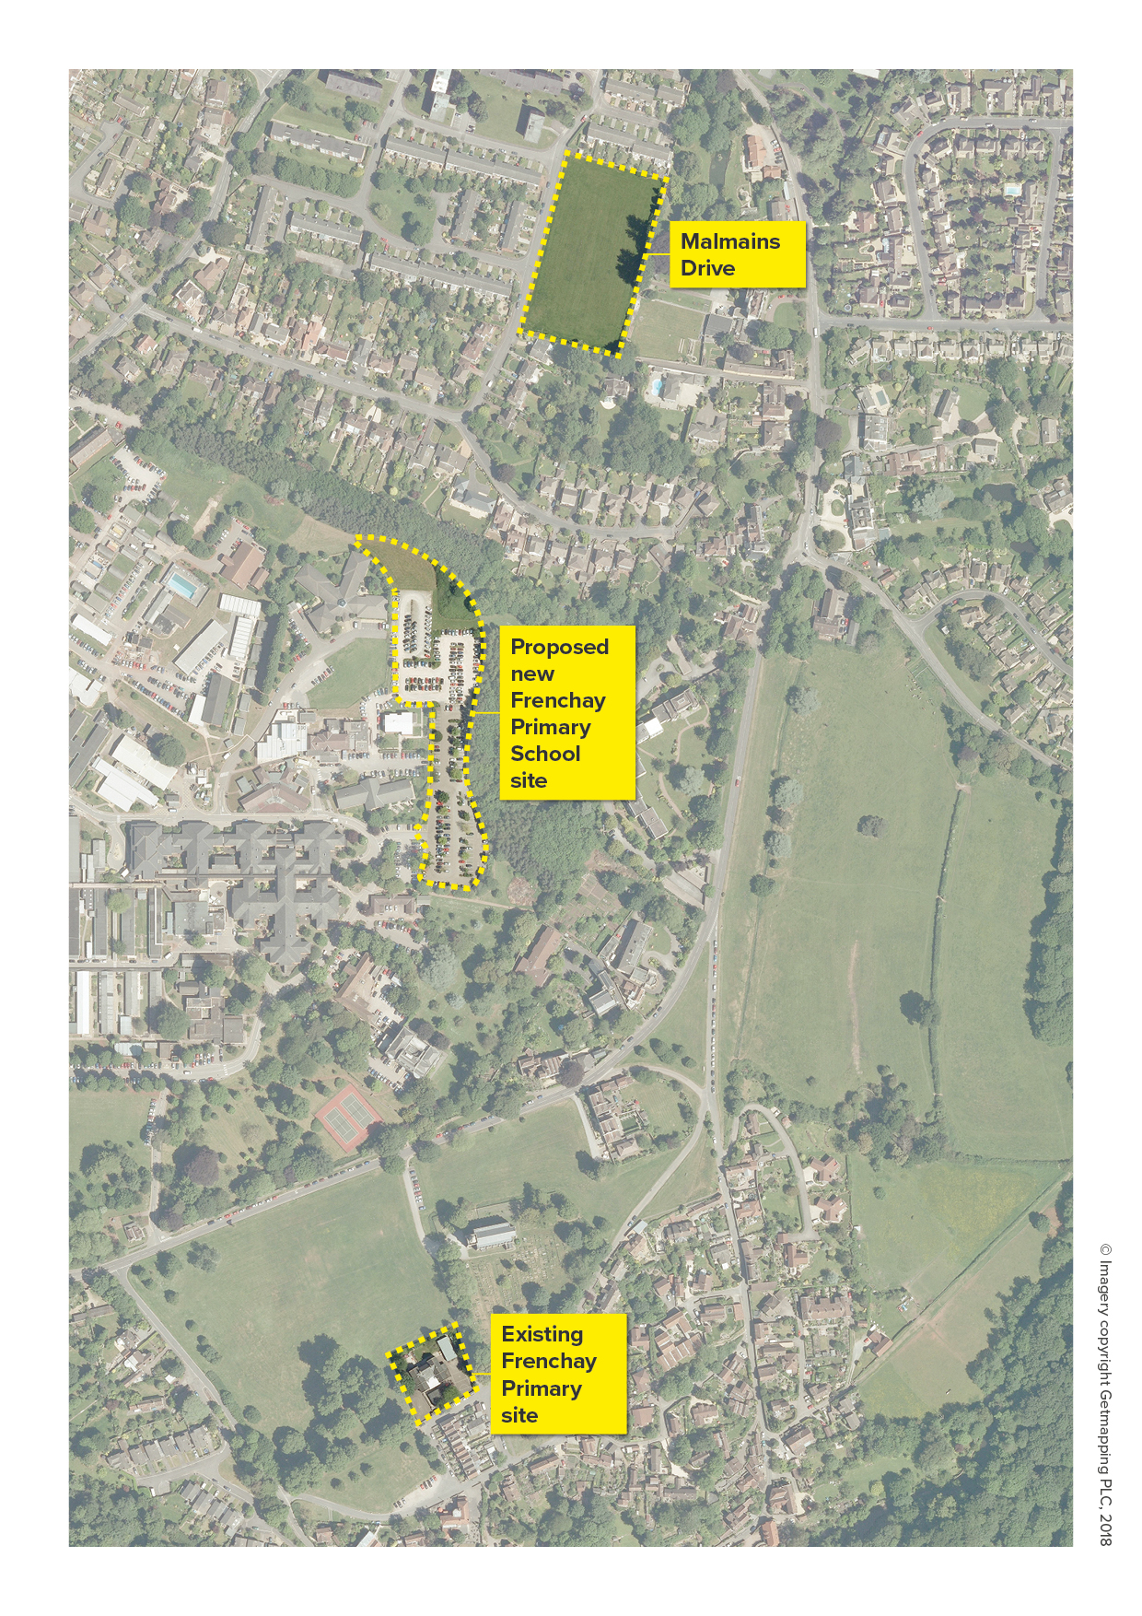

DEPARTMENT FOR CHILDREN, ADULTS AND HEALTH

PROPOSAL TO ENLARGE FRENCHAY CE PRIMARY SCHOOL

I would like to make the following comments on the proposal to enlarge Frenchay CE Primary School:

Please continue on a separate sheet if necessary

Please indicate below (tick box), if you wish, which of any of the following apply to you

I am:

- a parent/carer of a pupil currently attending Frenchay CE Primary School

- a parent/carer of a pupil currently attending another school

(please state school) …………………………………………………………

- a pupil currently attending Frenchay CE Primary School

- a pupil currently attending another school

- a governor of a school (please state school)

.................................................................................................................

- a teacher or non-teaching staff (please state school)

.................................................................................................................

- a local resident

..........................................................................................................……

- other interested party (please give details)

..........................................................................................................……

Thank you for taking the time to share your views on this proposal.

Email your comments to: tanya.smith@southglos.gov.uk

Or by post at the following address:

Tanya Smith
Strategic Lead - School Place Planning
Department for Children, Adults and Health
PO Box 1955, Bristol. BS37 0DE

Please ensure that your comments reach the Council by 5pm on Wednesday 24 January.

